
Summer term 2026

Welcome Back!
Hope you all had a restful and rejuvenating break whether you ventured from home or just got on with jobs at home that term time doesn’t allow for. Not too many Easter eggs we hope! At least we got to see a bit of sunshine over the break!

Useful Resources:
Staff wellbeing:
I have been highlighting for a while the positive work www.educationsupport.org.uk/ does to support people who work in a school setting.
We attach two articles to this email from Education Support which you may find helpful or wish to share when you are in school.

Mindfulness in Schools Project:
Co-op Wholesale’s charity, Making a Difference Locally’s (MADL) generous initiative offers full funding for educators based in the UK in a state maintained school or educational setting to train with MiSP.
You can apply for fully funded training for Teachers or TAs for online opportunities. The programmes sound great!

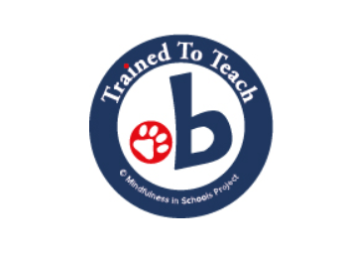
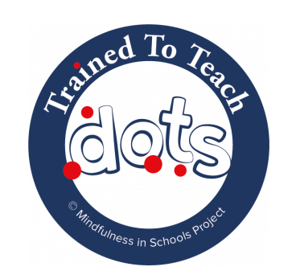

Dots is for 4-6 yr olds Paws is for 7-11yr olds
Find out more here https://mindfulnessinschools.org/school-mindfulness-lead/

Reading support:

The work of this organisation has come to our attention and they work with primary schools to support a whole-school reading culture through our range of programmes. We want to ensure the right resources, support and investment go to the children who need us most. https://www.bookmarkreading.org/schools They also work with reading volunteers, which might be something you want to share also https://www.bookmarkreading.org/volunteer

Bridge the Gap support:

We have started to work with Bridge the Gap to promote the emotional resilience and development of our children. This is a tremendous organisation who provide outstanding support through a range of options and packages. If the need is there in your school do give them a call. https://www.jwbridgethegap.com/supportpackagesforchildrenderbycitychildmentalhealth

School/ National Initiatives in this next half term:
Take a look at https://www.weare-css.co.uk/news/ section of the website.
This term, we have Mental Health Awareness Week, Earth Day, World Book Night, National Libraries Week.




Spread the good news!
If you are particularly impressed by a member of staff we have sent to you, please let Jo know with a few lines why, so we can share the positives here. https://www.weare-css.co.uk/reviews/ We have also had staff coming back with positive feedback about the schools and the support / welcome you give them, which is also lovely to share.

Have a good term and keep in touch!
From your Claire’s team .



