
Summer term 2026

Welcome Back!
Hope you all had a restful and rejuvenating break whether you ventured from home or just got on with jobs at home that term time, doesn’t allow for. We have received lovely messages from some of you telling us about your hols and also had a few visits from some of you when you have been out and about. It’s is always nice to see you.
Availability:
Please can you remember to let us know of your availability every week as this really helps Sarah and Katie when they are trying to allocate staff in the mornings.
Remember that we are entering the busiest term with regard to supply, so please :
Turn on your phone in the morning
If you are up for work that day, text the work phone to let Sarah and Katie know you are there and ready.
Continuing Professional Development:
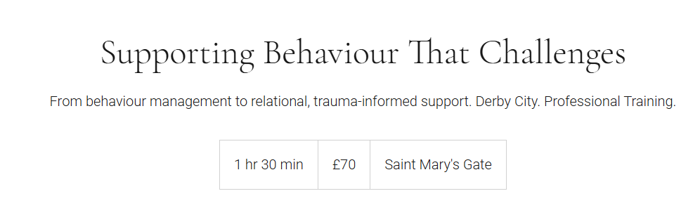

You may have seen an email from Jo in the holidays about course opportunities.
This is ran by Bridge the Gap and is coming very soon Tuesday 14th April 9:30- 11
if you are interested, you can book via the link https://www.jwbridgethegap.com/service-page/behaviour-that-challenges-training-derby?referral=service_list_widget

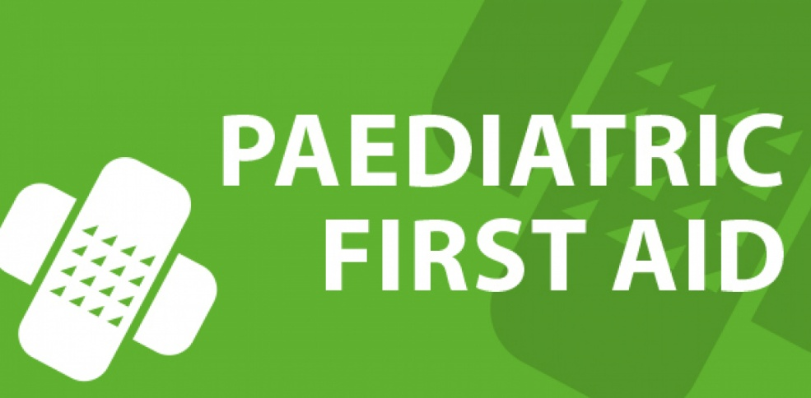
We have a few spaces left for the Paediatric First Aid course we are running again in May half-term. We are just locating a possible venue then will be able to give you the exact date. There is a cost to this for you of £110 payable to the trainer but the participants felt it was all very worth it when we ran this last time. This would be incredibly useful if you work regularly in Nursery or EYFS. Please email Jo if you are interested.
Need support?
All year, we have been highlighting the positive work www.educationsupport.org.uk/ does to support people who work in a school setting.
Tour of our website:
Coming soon, there will be a video tutorial on the educational content of our Claire’s website. As Jo is an ex head and teacher of 29 years, she is constantly added to this content in the blogs, news and reviews and Claire’s staffroom section of the website. We believe this content puts us head and shoulders above other supply agencies, which do not have this ‘string to their bow’.

Have a good term and keep in touch!

From your Claire’s team .


