

Have a look inside your lunchbox and see how many materials you can see. Are there any swaps that could be made?
What is in my lunchbox? 
Material found | Are they single use or multi use? | What swap could you make? | Can it be recycled?
Eg: cling film on sandwich | Single use | Sandwich container | 
How many of the materials that you found can be recycled? 
can be recycled?

Word bank: Plastic, paper, cardboard, organic waste (eg banana peel) cling film, tin foil, yoghurt tube, sandwich bag, bottle

What is in my lunch box lesson ideas.
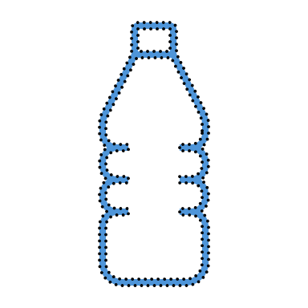
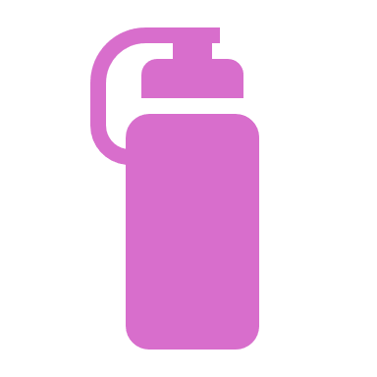

Avoid
Plastic bags, cling film, foil.
Disposable drink boxes, cans, cartons, bottles
Disposable forks, knives and spoons.

Pack
A reusable lunchbox
Snacks and sandwiches in reusable containers.
Drinks in reusable bottles
Reusable utensils

Waste Free Lunches

