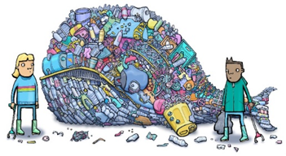
Design your own litterbug

A litterbug is the name given to a person who drops litter. But what would a litterbug look like?
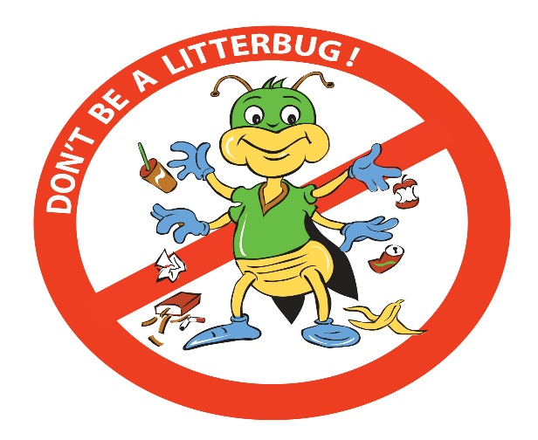
Look at the pictures of Litterbugs below to get some inspiration.
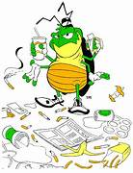


The Pennsylvania Litterbug @armaghbanbridgecraigavon.gov.uk
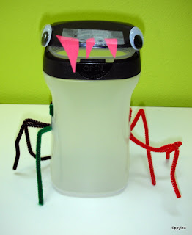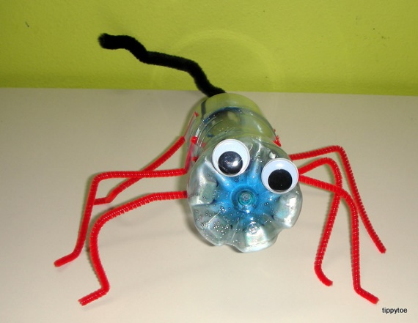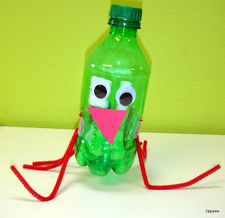
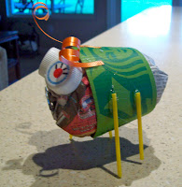
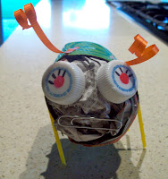
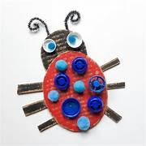
@tippytoecrafts

@yearn4learning @kidlabraleigh


You can draw your own litterbug, or better still made one from litter or recycled material. Try not to use anything new.
Design your own litterbug

A litterbug is the name given to a person who drops litter. But what would a litterbug look like? Chat with the people on your table.
What would their personality be? Would they care about what they are doing to the world?
My Litterbug is called:

D
Describe the personality of your Litterbug.

