The Life of a Duracell Bunny!

From the minute I open my eyes in the morning…‘On your marks, get set… GO!’

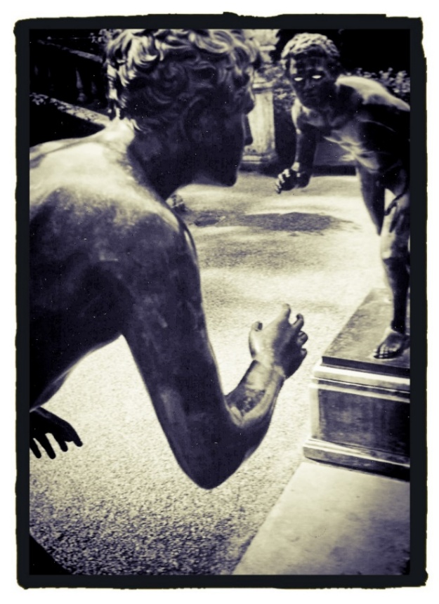

How much of our ‘set up’ is genetic or acquired as a result of our environment, both at home and school or work, neurological or self-learnt? In our current society, ADHD (and to a degree, autism) is a term ‘banded around’ arguably too freely at times. As a teacher, much has changed in 29 years. Even more so since my mum taught those pupils who were in some way ‘unteachable’—finding strategies built on trusting relationships that would keep them in the classroom and, on a good day, educate them.
All too often, fidgeting, constant chatter, answering back, and general disengagement were put down to parenting (or lack of it) or worse still, a ‘learning disability’— a term I vehemently object to with good reason. In Mum’s final weeks, I was privileged to be able to make contact with many of her ex-pupils, some in their seventies themselves. They were keen to send messages about their memories of her and words of thanks to be read by a former colleague at her funeral. What a blessing that she could hear these herself! The influence teachers can have on us is a chapter in itself…but many of these pupils expressing love and thanks to mum were exactly those who were hard to reach, were experiencing problems at home, or those who we would now say had ADHD.
Yet when it came to my own diagnosis at the age of 50, confirming what I had probably known for many years, Mum was somewhat sceptical and took some convincing about how accurate this term was in describing her intelligent, well-behaved daughter. Having always been ‘a good girl’ who worked hard, was bright (not a genius by any means), but was able to conform to convention, I can see why this was a shock. There was also an element of her feeling ‘responsible’ in some way and having ‘failed’—of course, this was not in any way the case.
It is extensively researched that ADHD in females manifests itself in different ways and can be ‘masked’ for many years. I am writing not from a stance of extensive research but from personal experience. Since diagnosis, I have been blessed with insight—through new glasses—on how this has shaped me, affected my decisions and been the reason behind much of what has happened in my life.
My journey to this enlightenment started with a mum of an ex-pupil asking me to complete a detailed form about her vivacious, creative 12-year-old, from my perspective as her former teacher. She most certainly did not ‘fit’ the previous mould of other pupils I had taught with ADHD. However, when completing the form, I was surprised by some of the indicators which were outlined.

- Attachment to adults—seeking praise, affirmations from them rather than peers of their own age.
- High functioning—overly committed to their interests/ passions.
- A tendency to be overly emotional or anxious if plans change or friendships change.
Not just the fidgety, ‘ran like a motor’ characteristics I had known in boys of this age.
As I filled out the form relating to this beautiful, talented, but yes, spirited girl, I saw my own daughter, but indeed myself. When handing the form over (completed from a place of fondness, not criticism), I knew what I needed to do.
Once you embark on an adult diagnosis, you are potentially opening up mysterious Pandora’s Box, disturbing a long-established ants’ nest, or poking a very unpredictable bear.
There is no right or wrong about whether a diagnosis should be sought, equally whether, if verified, medication should be taken. What is needed is true honesty from oneself and those who know you best. My mum may have found it hard to accept due to a lack of awareness, which led her to misunderstand what ADHD in females would look like.
My only ‘regret’ is in not seeking this diagnosis within my dad’s lifetime, for I know with true certainty that this was his truth, too. His inability to manage money, need to overspend, hyperemotional, having a daily to-do list, being an early riser and being passionate about his interests to the point of obsession were all traits he and I shared. However, an honest dialogue with Mum about how similar her two most loved ones were, led her to eventually not view this as a negative.
Thankfully, Mum’s memory was something that never failed her, so she was able to look back at the pre-teen Joanna, who was a bundle of energy, a natural entertainer, seeking adult company, always ‘on the go’ and a reluctant sleeper. I recall many a night where an exasperated mum and dad would send me back to bed after my sixth trip down the hall to give them another reason why I couldn’t sleep. I also recall (with more sadness) nights in my teenage years, sobbing uncontrollably, Mum adopting the tough love approach, and Dad succumbing with cuddles to try to settle me.
My inability to control these extremes of emotion often led to a pause in breathing (what I now suspect was some form of panic attack), meaning that Mum and Dad would have to deal with me, whether they wanted to or not. I’m not proud to admit that similar behaviour has been present in adult years, with my ever-patient husband taking a similar approach as Mum—wanting to ‘leave me be’ until morning in the hope that I will have calmed down. The trouble is…my ADHD means I won’t settle until whatever the trigger was, had been ‘put to bed’ or resolved. This can sometimes lead to more self-sabotage, cries for help which won’t be left unheard and self-inflicted carnage! I am the first to admit that this version of myself is not pretty!
I found it incredibly hard to look back at childhood behaviours through adult eyes, but it was a revelation to try. I know I was a model pupil; therefore, many of my former teachers would be surprised by this adult diagnosis. However, aside from my extreme emotions, I was also constantly filling my time with numerous interests, with my bedroom reflecting this, but it also reflected a cluttered mind. I had flashbacks to the piles of precariously stacked miscellanea wedged beside my bed or next to my much-loved stereo system. A wardrobe full of clothes randomly ‘shoved’ in, hidden from view, but lacking any organisation. Every inch of space under the bed, occupied by ‘God knows what’.
The feelings of stress this bedroom caused within me, when each weekend I vowed to clear it out, but then, when looking at the task, it was too high a mountain to climb. Therefore, I would not bother. An attitude to hoarding and disorganisation, fed by a denial that both parents clearly shared, if their loft was anything to go by!
Again, this would probably surprise my previous colleagues who have only ever known me to be highly organised, methodical and sure to have ownership of a shipshape classroom with labels on anything that wasn’t moving! Those who live with me would say I am still fond of clutter. They may be partially correct. But now, if my mood is affected by the untidiness of my living space, I will tackle it. I will never be a Mrs Hinch figure, and we joke that ‘over-cleanliness’ makes me come out in hives! However, maturity has taught me that when my traits impact on my mental health, it cannot be ignored.
The most powerful aspect of my diagnosis at 50 was that it gave me reasons why I had acted/reacted as I had to life events. I have accessed professional talking therapies over the years (to varying degrees of success), but none has quite helped me understand myself as much as this diagnosis. With this acceptance came a release from the shackles of guilt. Why? Because I was able to come up with the following equations.

- A predisposition to hormone imbalance + lack of ability to control a situation (ADHD) = post-natal depression.
- A perfectionist streak + a tendency to overwork = a stress-induced stroke.
- A lifetime of racing out the house at 7:20 am, recklessly driving + a passion for teaching, meaning I want every aspect to be fully prepared = 29 years of anxiety-filled mornings.
- A tendency to feel extremes of emotion + a mum and husband who were ‘annoyingly’ passive and calm = angry Jo!
- An obsessive/addictive nature + a love of food = a cycle of destructive food habits of overeating and extreme dieting.

However, for all of these equations that were not healthy, there were elements of my ADHD that I was able to view as a ‘superpower’. Please accept that any tone of self-praise is not arrogance and has taken a lifetime for me to believe.
- A natural ability to teach + a commitment to professional development (completing at least five additional courses) = a successful career of 29 years.
- A tendency to feel extremes of emotion + an emotional awareness/ intelligence = many lasting friendships with friends/ pupils and colleagues.
- An early riser + high levels of motivation = I get things done!
- A perfectionist streak + a creative spirit = when I have a dream, I don’t let it go, and this has led to what lies before you on these pages.

Our attitudes to our strengths and weaknesses can only be ‘reframed’ by ourselves. For every aspect of my ADHD that had the potential to damage, there were as many aspects that have led to success and happiness.
I have reflected on whether an earlier diagnosis would have been preferable, and the only time I think this would have been true is after the birth of my daughter. If I had a label to hang my feelings on, it may have led to greater support from professionals, but I will never know that. The hormonal aspect may still have taken a strong hold, as it did in the menopause, but it maybe would have meant I didn’t punish myself as much.
A later-in-life diagnosis was instrumental in my decision to ‘draw the curtains’ on my teaching career. The early morning hyperactivity is still present (even with medication), but it will not result in me speeding out of the house jam-packed full of anxiety. I can now have a slower sip of my coffee and a 10-minute immersion in cold water—something which has helped me enormously.
For those who have lived and worked with me, primarily, ‘I’m sorry’. But only for the times when my internal battery speed has led me to anger or intolerance of others more relaxed behaviours. I will never apologise for my ADHD, as it is starting to be what I like most about myself. But it does need managing. My most successful friendships/working relationships have been when paired with someone who is less fast-paced but equally talented and who has never wanted to change me. The yin to the yang and all that! Ironically, post-diagnosis, I have actively sought quiet slots each day and have been the calmest I have ever been. What this can be attributed to is up for debate. Is it…

- Effective medication.
- Opting out of a 9-5 pressured work environment.
- A release from the demands of caring for my parents.
- Or simply…acceptance.

There is still, and always will be, I hope, times where the Duracell bunny is released. I thrive in a busy, social gathering. I often get an extra ‘wind’ after 12 o’clock at night. I intend to go out ‘all guns blazing’ at my funeral to the sound of ‘Dancing Queen’, nothing solemn, still or mundane.
But this bunny is starting to know when she needs to rest. She knows herself and has felt like the light bulb has been turned on after 50 years of blurred confusion.

