How long will litter last?
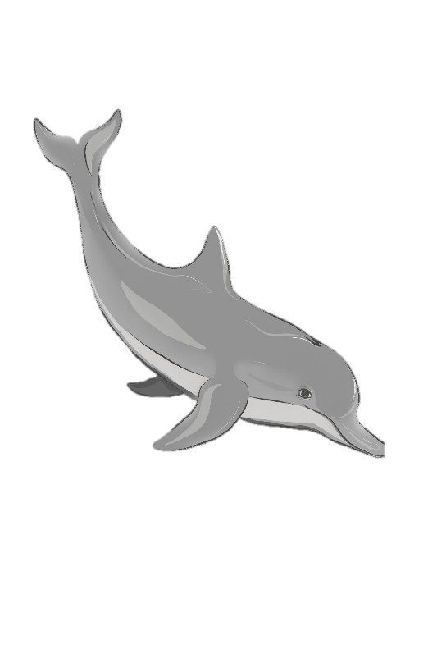

Litter can hang around for a VERY long time!
Think what material the item is made from and how long it could last before biodegrading.
Match each object on the left to a time duration on the right.
Prepare for a shock!


500 years
Plastic bottle


200 years
Cigarette butt

5 years

Plastic straw







Paper bag
Plastic toothbrush
Fishing line

Disposable nappy

400 years
never
1 month
500 years
Glass bottle
600 years
How long will litter last? Answers

Litter can hang around for a VERY long time!
Think what material the item is made from and how long it could last before biodegrading.
Match each object on the left to a time duration on the right.
Pre[are for a shock!


500 years
Plastic bottle






never
1 month
500 years
Glass bottle
Paper bag
Plastic toothbrush
400 years
Fishing line

Disposable nappy

5 years
Plastic straw
200 years
Cigarette butt
600 years


