


Welcome Back for the final term! June 2026

Wow! What a scorcher half-term was! Hope you were able to stay cool and take some time for yourself.
We may only have 8 short weeks of the academic year left, but look after yourself and remember that you are the most important resource the children have. We like this image which shows just how much is expected of teachers in the working day. Don’t underestimate what your role is, but look after yourself.
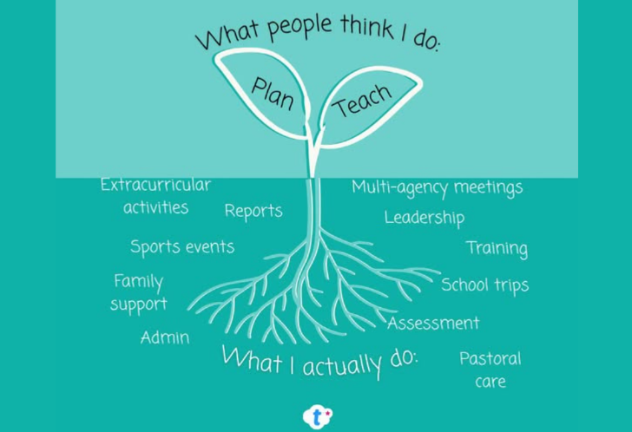

Talk to us!
Thank you to those of you who have updated your profile builders and let us know your wishes for September. If this is still on your ‘to do’ list, please try to prioritise this so that we can best place you in the right job.

Your Claire’s School Solutions Educational support:
The latest national and school events section of the website has been updated – as well as this being the term for sports days, school visits, end of year performances and dare we say, reports… there are lots of other interesting things happening.

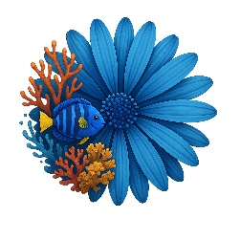
June is Pride month World Ocean Day Thank a Teacher Day


But there is plenty more to come… take a look at the news section of our website for more and signposts to helpful resources https://www.weare-css.co.uk/news/
We will also be adding online courses on that same page that you might be interested in over the next few months. If you do sign up for any of these, do let us know and any feedback.

Before the holidays, we told you about the new section of the website where you can submit a question relating to educational content, guidance or a school related dilemma. All you have to do is click on the pink button of this section of the website and it will send your question to Jo directly. She will then attempt to respond to it as soon as she can, keeping it anonymous if you wish, but signposting you to any advice or solutions which might help.
https://www.weare-css.co.uk/members-q-and-a-forum/

We are heading for the finish line as we start June, but remember, as someone famous said:
"Life is a marathon, not a sprint; pace yourself accordingly".


As always, you know where we are if you need a chat…

From your Claire’s team

