Reading and Using Texts – Mary Seacole

Mary Seacole was born in Kingston, Jamaica in 1805. When she died in 1881, her story was forgotten. But today, Mary Seacole is very well known for her bravery and determination.

For someone living more than 150 years ago, Mary had an adventurous life travelling

across many lands to run businesses and help people in need.

Her dad was a Scottish soldier and her mum was Jamaican, so Mary was mixed race. Mary's mum ran a hotel where wounded soldiers sometimes stayed. She taught Mary how to use plants to help care for them. As a young adult, Mary travelled all over the world (including Britain), to learn more about modern medicine.

She later returned to Jamaica when a terrible disease called *cholera* spread across

Kingston. Mary helped those who were sick. Later, Mary travelled to Panama to help their

Questions

1. Was Mary Seacole remembered *throughout* history?

Use the text to support your answer.

1. When and where was Mary Seacole born?
2. Why was Mary’s life considered as ‘adventurous’?

Use the text to support your answer.

1. Was it important that Mary travelled as a young adult?

*Explain your answer*

1. Which disease was Mary particularly good at caring for?
2. Why do you think Mary was needed in Panama?

*Look for the V.I.W (very important word) in the question.*

*Then, use your scanning skills to find that word (or one similar) in the text!*



**V.I.W**

*Remember…*

people with an outbreak of the awful disease.

When Britain sent soldiers to war in Crimea (now called Ukraine) in 1853, disease was more dangerous than the enemy. Thousands of soldiers died from it. Mary knew how to treat cholera; therefore, she wanted to go to Crimea as a military nurse. After travelling all the way to England, she wasn’t chosen.

Mary went anyway, using her own money to pay for her journey. When she reached Crimea, she set up a make-shift hotel right on the battlefront. This wasn't like a hotel you would stay in on your holidays; it was just a hut made from metal. She sold hot meals and looked after the wounded and sick soldiers. Bravely, she also went onto the dangerous battlefield to help soldiers.

But helping the soldiers cost so much money that when the war ended Mary was very poor. To pay her debts, she wrote a book called ‘The Wonderful Adventures of Mrs Seacole in Many Lands’. After she died, people forgot Mary Seacole, but we remember her today as a woman of mixed race who lived an exciting and unusual life. In 2004, she was voted the *Greatest Black Briton.*

1. Explain what is meant by *‘disease was more dangerous than the enemy’*
2. 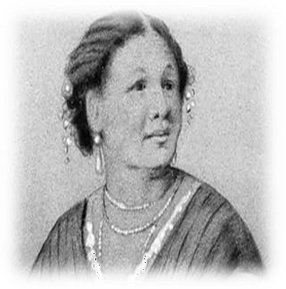What type of personality do you think Mary had?

*Use the text to explain your answer*

1. Can you find an *expanded noun-phrase* within the text?

*Find and copy from the text.*

1. Why did it cost Mary money to look after the soldiers?

*Explain your answer.*

1. Mary was forgotten for many years. Why do you think this was?

*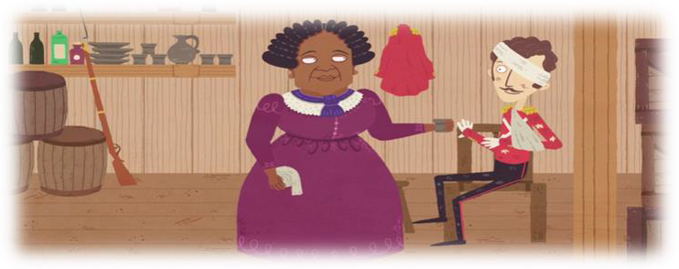Explain your answer.*

1. In what year was Mary voted

*The Greatest Black Briton?*

1. Why did Mary write a book?