A FREE RESOURCE PACK FROM EDUCATIONCITY



EducationCity

Black History Month

5-11

Classroom Resources

Age Suitability

Free school resources by EducationCity. This may be reproduced for class use.

What Does This Pack Include?

Black History Month Topical Teaching Resources

This pack has been created by teachers for teachers. In it, you’ll find high quality teaching resources, including Fact Sheets and Lesson Plans, to help your students celebrate Black History Month.

To go directly to the content, simply click on the title in the index below:

|  |  |  |  |
| --- | --- | --- | --- |
| FACT SHEETS: | | | |
| 1. Martin Luther King | 2. Black Inventors | 3. Mary Seacole | 4. The Slave Trade and the Abolition of Slavery |
| Learning Objective: Learn about Martin Luther King and his contribution to the civil rights movement. | Learning Objective: Learn about some of the most famous black inventors, what they invented and their lives. | Learning Objective: Learn about Mary Seacole, her battle to nurse in the Crimean War and her life. | Learning Objective: Learn about the history of slavery and its abolition. |

|  |  |  |  |
| --- | --- | --- | --- |
| LESSON PLANS: | | | |
| 1. Civil Rights | 2. African Mask | 3. World Dream | 4. Civil Rights Timeline |
| Learning Objective: Consider the civil rights movement since the death of Martin Luther King  in 1968. | Learning Objective: Explore the importance of African tribal masks, and then ask your students to create their own. | Learning Objective: Consider the ‘I Have a Dream’ speech and ask your students to write a similar one for their school dream. | Learning Objective: Explore the importance of Martin Luther King’s speech and why it was so important. |
| 70 minute Lesson Plan | 60 minute Lesson Plan | 60 minute Lesson Plan | 60 minute Lesson Plan |

## EducationCity

EducationCity

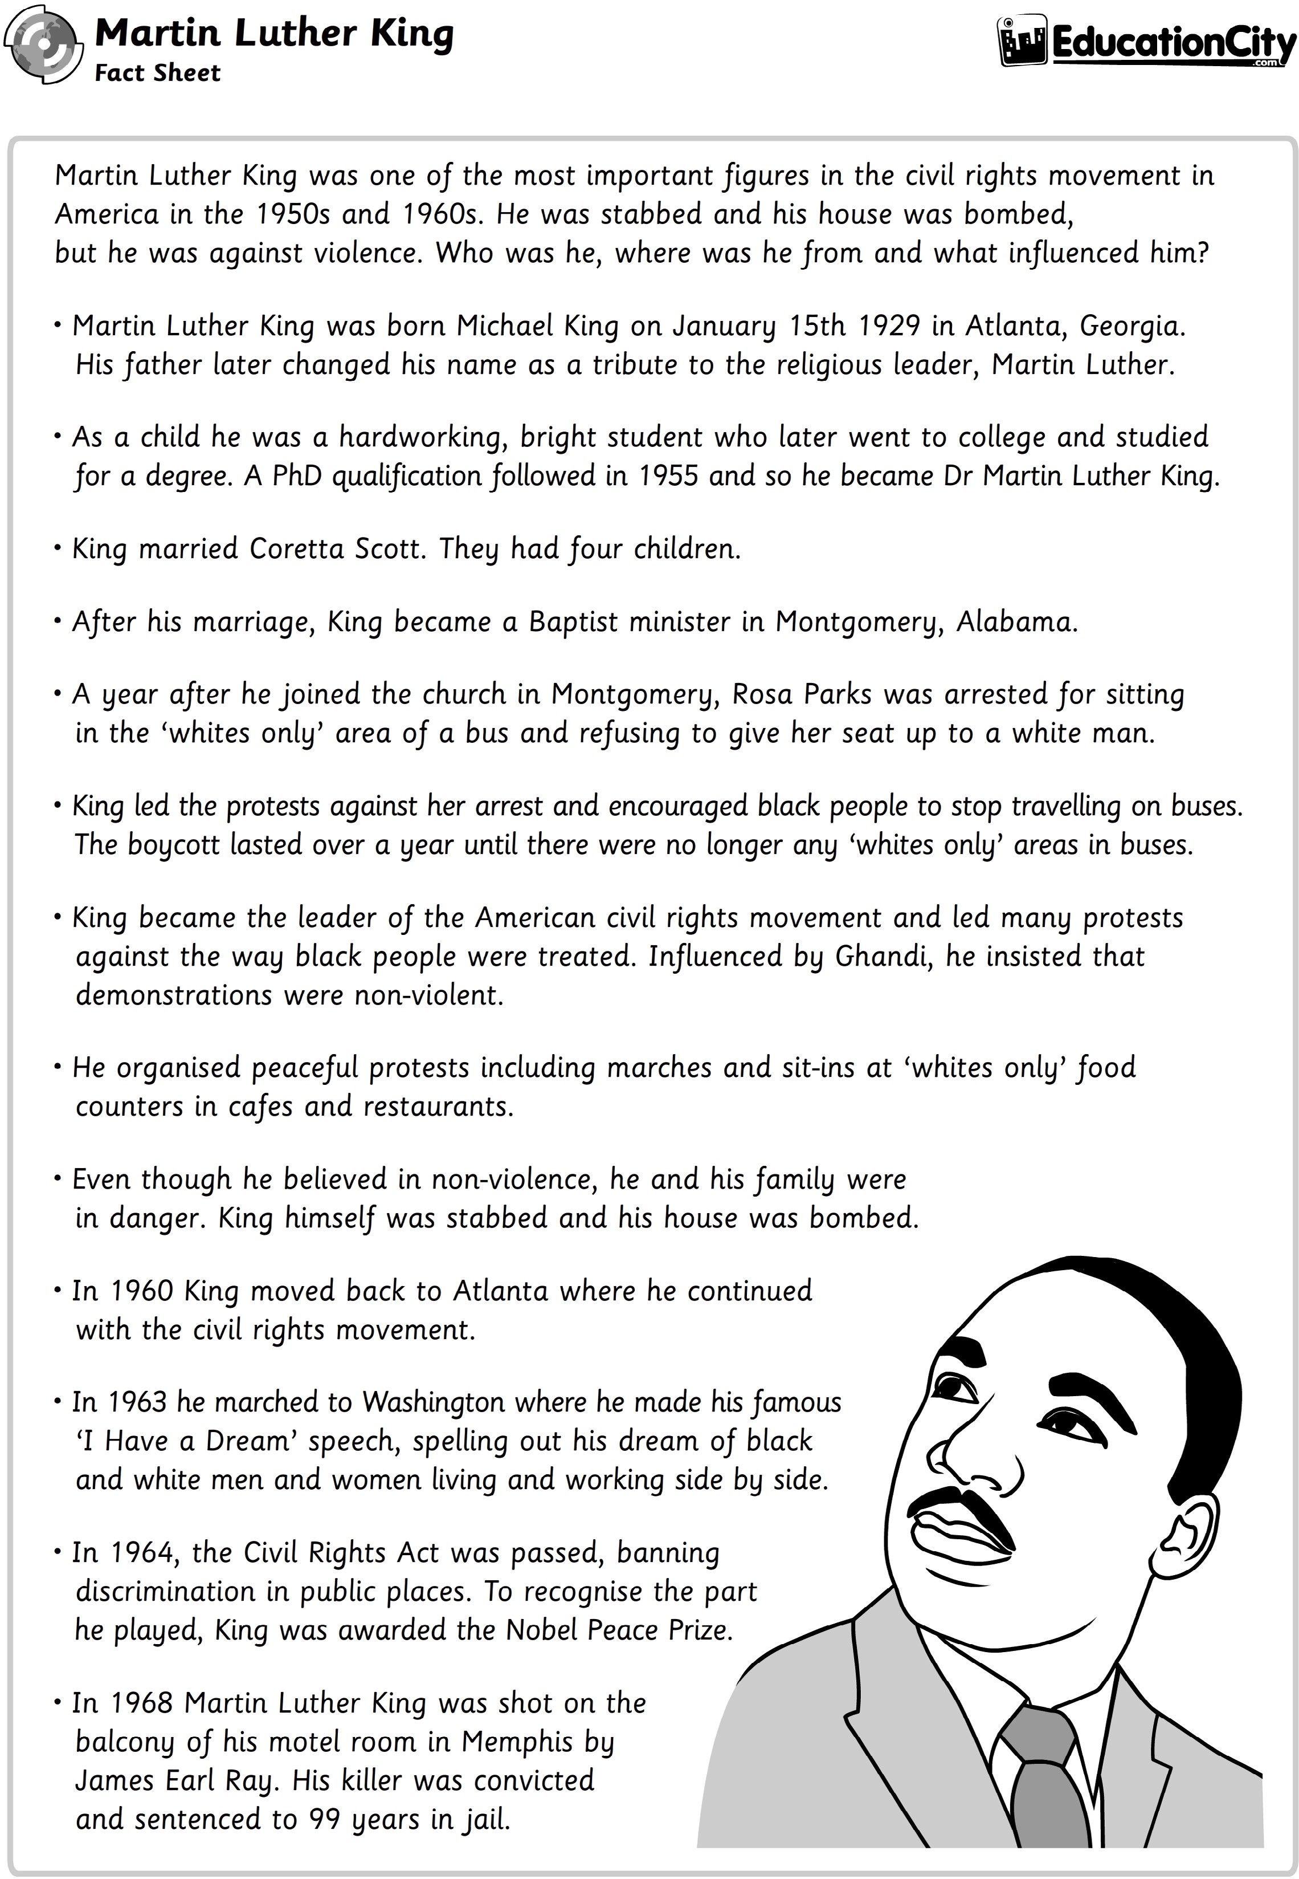

*Martin Luther King was one of the most important figures in the civil rights movement in America in the 1950s and 1960s. He was stabbed, and his house was bombed, but he was against violence. Who was he, where was he from and what influenced him?*

* *Martin Luther King was born Michael King on January 15th 1929, in Atlanta, Georgia. His father later changed his name as a tribute to the religious leader, Martin Luther.*
* *As a child, he was a hardworking, bright student who later went to college and studied for a degree. A PhD qualification followed in 1955, and so he became Dr Martin Luther King.*
* *King married Coretta Scott. They had four children.*
* *After his marriage, King became a Baptist minister in Montgomery, Alabama.*
* *A year after he joined the church in Montgomery, Rosa Parks was arrested for sitting in the ‘whites only’ area of a bus and refusing to give her seat up to a white man.*
* *King led the protests against her arrest and encouraged black people to stop travelling on buses. The boycott lasted over a year until there were no longer any ‘whites only’ areas in buses.*
* *King became the American civil rights movement leader and led many protests against the way black people were treated. Influenced by Ghandi, he insisted that demonstrations were non-violent.*
* *He organised peaceful protests, including marches and sit-ins at ‘whites only’ food counters in cafes and restaurants.*
* *Even though he believed in non-violence, he and his family were in danger. King himself was stabbed, and his house was bombed.*
* *In 1960, King moved back to Atlanta, where he continued with the civil rights movement.*
* *In 1963, he marched to Washington where he made his famous ‘I Have a Dream’ speech, spelling out his dream of black*

*and white men and women living and working side by side.*

* *In 1964, the Civil Rights Act was passed, banning discrimination in public places. To recognise the part he played, King was awarded the Nobel Peace Prize.*
* *In 1968, Martin Luther King was shot on the balcony of his motel room in Memphis by James Earl Ray. His killer was convicted*

*and sentenced to 99 years in jail.*

EducationCity

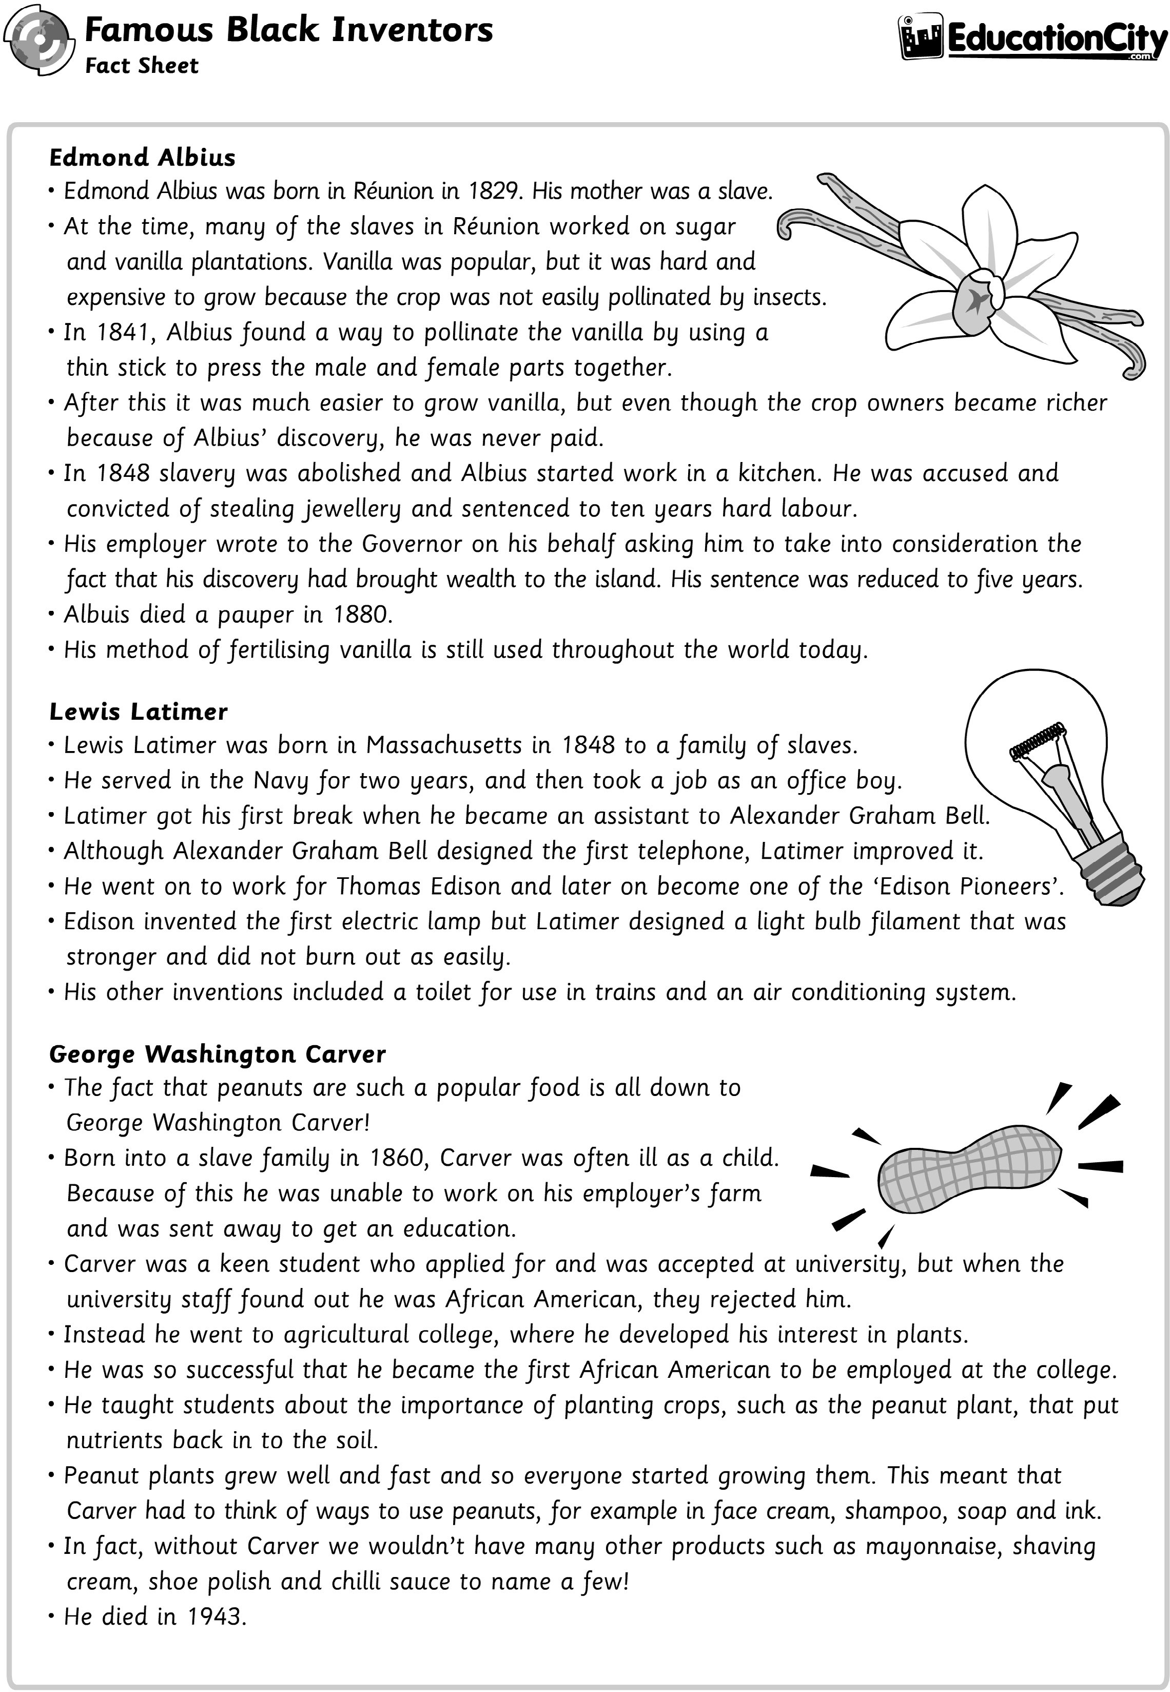

### *Edmond Albius*

* *Edmond Albius was born in Reunion in 1829. His mother was a slave.*
* *At the time, many of the slaves in Reunion worked on sugar*

*and vanilla plantations. Vanilla was popular, but it was hard and expensive to grow because the crop was not easily pollinated by insects.*

* *In 1841, Albius found a way to pollinate the vanilla by using a thin stick to press the male and female parts together.*
* *After this, it was much easier to grow vanilla, but even though the crop owners became richer because of Albius’ discovery, he was never paid.*
* *In 1848, slavery was abolished, and Albius started work in a kitchen. He was accused and convicted of stealing jewellery and sentenced to ten years of hard labour.*
* *His employer wrote to the Governor on his behalf, asking him to take into consideration the fact that his discovery had brought wealth to the island. His sentence was reduced to five years.*
* *Albuis died a pauper in 1880.*
* *His method of fertilising vanilla is still used throughout the world today.*

### *Lewis Latimer*

* *Lewis Latimer was born in Massachusetts in 1848 to a family of slaves.*
* *He served in the Navy for two years, and then took a job as an office boy.*
* *Latimer got his first break when he became an assistant to Alexander Graham Bell.*
* *Although Alexander Graham Bell designed the first telephone, Latimer improved it.*
* *He went on to work for Thomas Edison and later on became one of the ‘Edison Pioneers’.*
* *Edison invented the first electric lamp, but Latimer designed a light bulb filament that was stronger and did not bum out as easily.*
* *His other inventions included a toilet for use in trains and an air conditioning system.*

### *George Washington Carver*

* *The fact that peanuts are such a popular food is all down to George Washington Carver!*
* *Born into a slave family in 1860, Carver was often ill as a child. Because of this, he was unable to work on his employer’s farm and was sent away to get an education.*
* *Carver was a keen student who was accepted at university, but when the university staff found out he was African American, they rejected him.*
* *Instead, he went to agricultural college, where he developed his interest in plants.*
* *He was so successful that he became the first African American to be employed at the college.*
* *He taught students about the importance of planting crops, such as the peanut plant, that put nutrients back into the soil.*
* *Peanut plants grew well and fast, and so everyone started growing them. This meant that Carver had to think of ways to use peanuts, for example, in face cream, shampoo, soap and ink.*
* *In fact, without Carver, we wouldn’t have many other products such as mayonnaise, shaving cream, shoe polish and chilli sauce, to name a few!*
* *He died in 1943.*

EducationCity

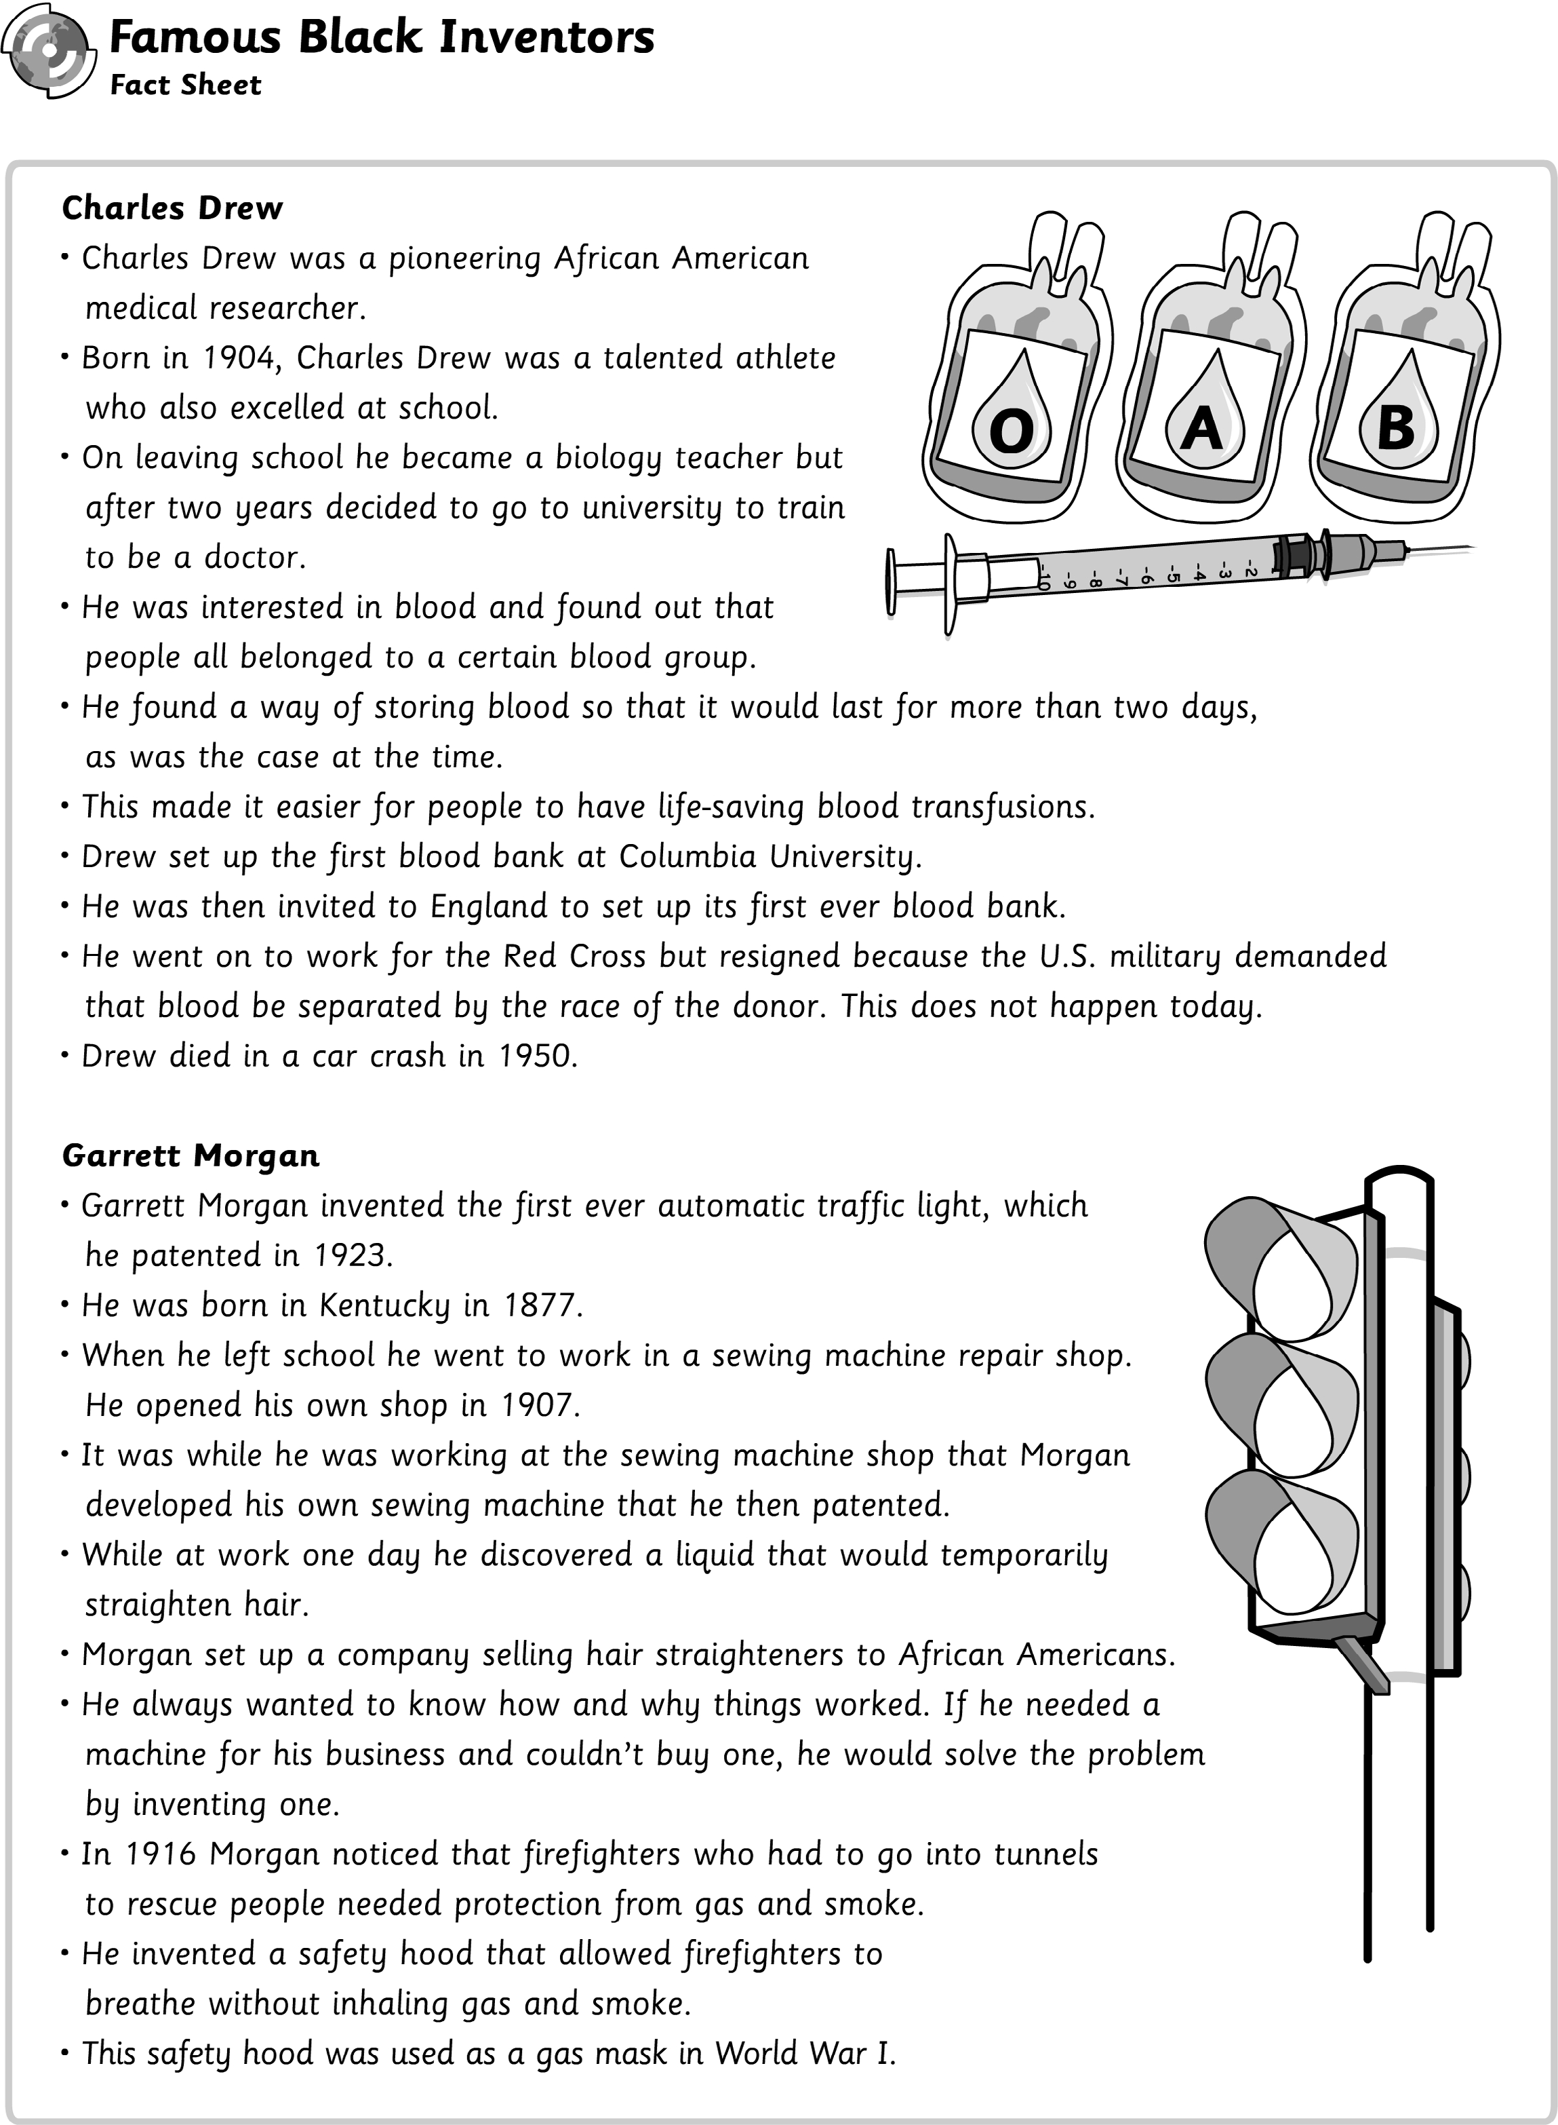

### *Charles Drew*

* *Charles Drew was a pioneering African American medical researcher.*
* *Born in 1904, Charles Drew was a talented athlete who also excelled at school.*
* *On leaving school, he became a biology teacher but decided to go to university to train to be a doctor after two years.*
* *He was interested in blood and found out that people all belonged to a certain blood group.*
* *He found a way of storing blood so that it would last for more than two days, as was the case at the time.*
* *This made it easier for people to have life-saving blood transfusions.*
* *Drew set up the first blood bank at Columbia University.*
* *He was then invited to England to set up its first ever blood bank.*
* *He went on to work for the Red Cross but resigned because the U.S. military demanded that blood be separated by the race of the donor. This does not happen today.*
* *Drew died in a car crash in 1950.*

### *Garret Morgan*

* *Garrett Morgan invented the first ever automatic traffic light, which he patented in 1923.*
* *He was born in Kentucky in 1877.*
* *When he left school, he went to work in a sewing machine repair shop. He opened his own shop in 1907.*
* *It was while he was working at the sewing machine shop, Morgan developed his own sewing machine that he then patented.*
* *While at work, one day, he discovered a liquid that would temporarily straighten hair.*
* *Morgan set up a company selling hair straighteners to African Americans.*
* *He always wanted to know how and why things worked. If he needed a machine for his business and couldn’t buy one, he would solve the problem by inventing one.*
* *In 1916, Morgan noticed that firefighters who had to go into tunnels to rescue people needed protection from gas and smoke.*
* *He invented a safety hood that allowed firefighters to breathe without inhaling gas and smoke.*
* *This safety hood was used as a gas mask in World War I.*

EducationCity

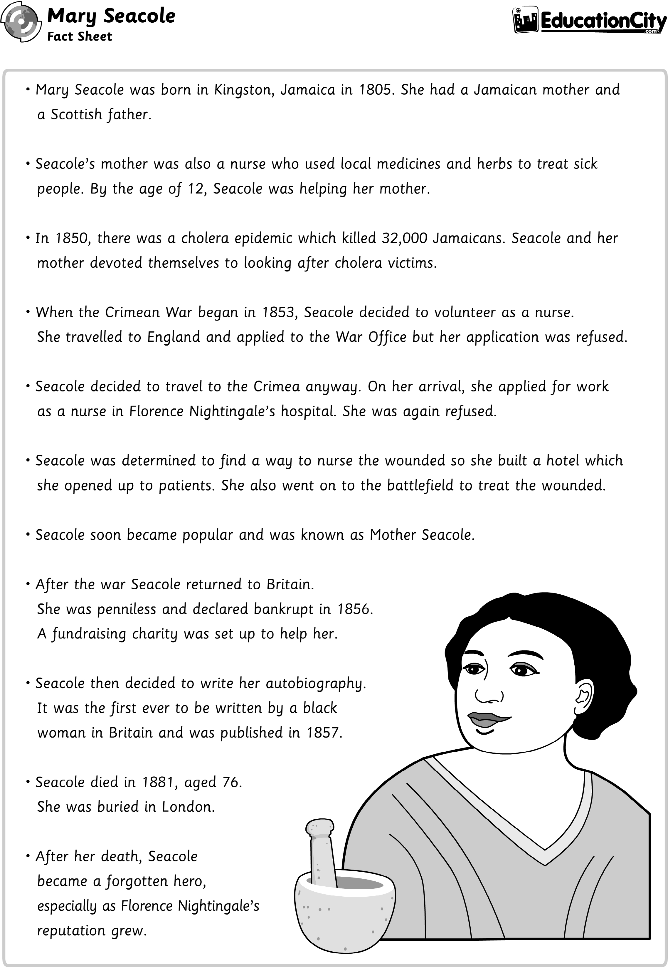

* *Mary Seacole was born in Kingston, Jamaica, in 1805. She had a Jamaican mother and a Scottish father.*
* *Seacole’s mother was also a nurse who used local medicines and herbs to treat sick people. By the age of 12, Seacole was helping her mother.*
* *In 1850, there was a cholera epidemic that killed 32,000 Jamaicans. Seacole and her mother devoted themselves to looking after cholera victims.*
* *When the Crimean War began in 1853, Seacole decided to volunteer as a nurse.*

*She travelled to England and applied to the War Office, but her application was refused.*

* *Seacole decided to travel to Crimea anyway. On her arrival, she applied for work as a nurse in Florence Nightingale’s hospital. She was again refused.*
* *Seacole was determined to find a way to nurse the wounded, so she built a hotel which she opened up to patients. She also went on to the battlefield to treat the wounded.*
* *Seacole soon became popular and was known as Mother Seacole.*
* *After the war, Seacole returned to Britain.*

*She was penniless and declared bankrupt in 1856. A fundraising charity was set up to help her.*

* *Seacole then decided to write her autobiography. It was the first ever to be written by a black woman in Britain and was published in 1857.*
* *Seacole died in 1881, aged 76. She was buried in London.*
* *After her death, Seacole became a forgotten hero,*

*especially as Florence Nightingale’s reputation grew.*

* *The United Nations International Day for the Abolition of Slavery is held on December 2nd every year.*

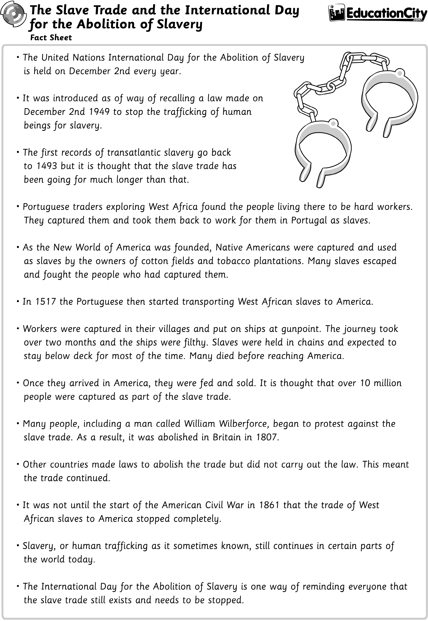

* *It was introduced as of way of recalling a law made on December 2nd 1949, to stop the trafficking of human beings for slavery.*
* *The first records of transatlantic slavery go back to 1493, but it is thought that the slave trade has been going for much longer than that.*
* *Portuguese traders exploring West Africa found the people living there to be hard workers. They captured them and took them back to work for them in Portugal as slaves.*
* *As the New World of America was founded, Native Americans were captured and used as slaves by the owners of cotton fields and tobacco plantations. Many slaves escaped and fought the people who had captured them.*
* *In 1517, the Portuguese then started transporting West African slaves to America.*
* *Workers were captured in their villages and put on ships at gunpoint. The journey took over two months, and the ships were filthy. Slaves were held in chains and expected to stay below deck for most of the time. Many died before reaching America.*
* *Once they arrived in America, they were fed and sold. It is thought that over 10 million people were captured as part of the slave trade.*
* *Many people, including a man called William Wilberforce, began to protest against the slave trade. As a result, it was abolished in Britain in 1807.*
* *Other countries made laws to abolish the trade but did not carry out the law. This meant the trade continued.*
* *It was not until the start of the American Civil War in 1861 that the trade of West African slaves to America stopped completely.*
* *Slavery, or human trafficking as it sometimes known, still continues in certain parts of the world today.*
* *The International Day for the Abolition of Slavery is one way of reminding everyone that the slave trade still exists and needs to be stopped.*

EducationCity

# Overview

Civil Rights Since the 1960s Lesson Plan

In this 70 minute activity, students consider the civil rights movement since the death of Martin Luther King in 1968. Through an interpretation of part of Martin Luther King’s famous speech, ‘I Have a Dream’, students reflect on the achievements of men and women that would not have been possible without the implementation of the 1964 Civil Rights Act. The research could act as an impetus for some further literacy work.

# Materials

Resources and organisation:

* Copies of the fact sheet on Martin Luther King.
* The following extract from Martin Luther King’s ‘I Have a Dream’ speech copied onto the interactive whiteboard:

#### *‘I have a dream that my four little children will one day live in a nation where they will not be judged by* the colour of their skin but by the content of their character.’

M. L. King, ‘I Have a Dream’, speech presented at the Lincoln Memorial, Washington, D.C., August 28th 1963.

* Access to the Internet.
* Organise the students into working partners.

# Lesson Structure

0-10 minutes Share the fact sheet about Martin Luther King with the students and draw their attention to the 1964 Civil Rights Act and King’s subsequent Nobel Peace Prize. Discuss with the students what type of man he was by asking them to draw out his characteristics.

10-20 minutes Introduce King’s famous speech entitled ‘I Have a Dream’, then draw the students’ attention to the part of his speech where King describes how he dreamt that children would be judged by their character rather than the colour of their skin. Ask the students to reflect on what he meant by this and discuss its importance. Elicit the understanding that without the work of the civil rights movement, making a speech like this would not have been possible.

20-40 minutes Ask the students to talk to their partners about whether they think Martin Luther King’s dream has ‘come true’. Discuss their thoughts and ask the students to think about what has happened in their lifetime to support this argument (e.g. the first black American president).

40-50 minutes Draw the class back together and ask them to share their findings by listing any achievements that they may have found.

50-60 minutes Finally, bring the children back to the question, asking whether they think that if Martin Luther King was alive today, would he have felt that his dream had come true.

*Follow up activities could include a newspaper report on one of the great achievements.

# Overview

Traditional African Masks Lesson Plan

In this 60 minute activity, students explore the importance of African tribal masks. They are then given the opportunity to design and make their own mask using papier-mâché. A simpler version could be made by using cardboard. Additional time is required to complete the masks.

# Materials

Resources and organisation:

* Pictorial examples of African tribal masks. These are freely available on the Internet.
* Allow access to the three different mask shapes that accompany this lesson plan.
* Resources for making the masks, e.g. newspaper, balloons, glue, cardboard, paints.
* Sketch books to record the design process.

# Lesson Structure

0-15 minutes Show the students pictorial examples of African tribal masks and ask them their initial thoughts when they see them. Ask the students to share their ideas and then discuss who might wear one and why. Through the discussion, elicit the understanding that mask making was traditionally passed down from father to son and that masks were used to retell traditional and religious stories. Explain to the students that there were three main types of masks – crest masks, helmet masks and face masks and that they portrayed both people and animals.

15-30 minutes Explain to the students that you would like them to design and make their own masks. However, as they will be using papier-mâché to make their masks, they will need to start making the papier-mâché base so that it has time to dry. Give each student a balloon, some newspaper and glue and ask them to cover half the balloon by building up layers of papier- mâché.

30-50 minutes While the papier-mâché is drying, start the students off on the design element. Explain the purpose of the mask, (i.e. to entertain) and ask them to consider what type of mask it will be, whether it is going to portray a person or an animal and the colours they plan to use. Ask them to incorporate their ideas into their design and then list the resources they will need and consider the process they will go through.

50-60 minutes Working in groups of six, invite the children to present their designs to each other. The other children in the group can peer assess the designs in terms of the design elements. Additional time is needed to make the masks. Once finished, the masks can be evaluated according to the design.

# Overview

‘My Dream for the World’ Lesson Plan

In this 60 minute activity, students reflect on Martin Luther King’s speech, ‘I Have a Dream’. They are then asked to consider why the speech was so important. Students are then asked to work in groups to think about what their dream for their school would be. A follow-up session is needed for them to record their dream either on paper, in the form of a speech or for voice recording. N.B. This lesson is designed to be used as a follow on from the plan on civil rights.

# Materials

Resources and organisation:

* Extract from the audio recording of Martin Luther King’s ‘I Have a Dream’ speech - it would be worth having the extract written on the IWB for more visual learners.
* Organise the students into talk partners and groups of four.
* Provide large pieces of sugar paper and felt-tip pens.

# Lesson Structure

0-10 minutes Explain to the students that you would like them to listen to an extract of Martin Luther King’s speech again. Play the speech and ask them to think about what his dreams were and why the speech was so important. Encourage them to make notes on individual whiteboards.

10-20 minutes Once the speech is over, ask students to identify one part of the dream that interested them in particular and ask them to think about why it was so important to both Martin Luther King and the wider population. Reinforce the idea that the speech was important for everyone and not just the black community.

20-30 minutes Explain to the students that you would like them to think about a dream they may have for their school community. As a class, discuss some ideas, possibly steering them towards

aspects of inclusion. It may be something relevant only to their class or one that affects the wider school population, e.g. an international day.

30-45 minutes Organise the students into groups of four and ask them to come up with their dream. Give them large pieces of sugar paper and felt-tip pens so they can record their ideas.

45-55 minutes Give each group time to present their dream to the rest of the class. It may be appropriate to engage the class in peer assessment where they consider the dream and the reasons behind it.

55-60 minutes In preparation for the next lesson, explain to the students that you would like them to think about how they could present their dream, e.g. they could make a poster, write their speech out or draft a script that they later record using a voice recorder. For this part of the activity, they could work in pairs or fours. A follow up session is required to complete the activity.

# Overview

Civil Rights Timeline Lesson Plan

In this 60 minute activity, students reflect on the civil rights movement taking into consideration the abolition of slavery and the need for Martin Luther King to make his speech. They then hear an extract from ‘I Have a Dream’ and are asked to consider why it was necessary. They then research the events leading up to the speech and consider why it was such an important day in history.

# Materials

Resources and organisation:

* Extract from the audio recording of Martin Luther King’s ‘I Have a Dream’ speech - have the extract written on the IWB for more visual learners.
* Copies of the fact sheet entitled ‘The Abolition of Slavery’.
* Access to the Internet and reference books so students can research the civil rights movement.

# Lesson Structure

0-15 minutes Show the students the fact sheet on the abolition of slavery and draw their attention to one of the final bullet points:

#### *“It was not until the start of the American Civil War in 1861 that the trade of West African* slaves to America stopped completely.”

Ask them in their talk partners to consider what happened to African Americans after this. For example, ask them, “Do you think that they were treated as equals from then on?

Why or why not?” After the students have had time to discuss, draw the class back together to share their thoughts.

15-30 minutes Explain to the students that people were still not treated equally and ask them if they have heard of Martin Luther King. Then play an extract from his speech. Provide some questions for them to think about as they listen to it, e.g. “What was Martin Luther King saying?”, “What was his dream?” and “Why do you think he needed to make the speech?” Give students time to share their thoughts with their talk partners and then with the rest of the class.

30-50 minutes Explain to the students that you would like them to research the events that led to the speech. Provide reference books and access to the Internet so they can carry out their research in pairs with one child making notes.

50-60 minutes Bring the class back together to discuss their findings. Ask them to reflect on whether Martin Luther King’s dream has come true.

*Follow up activities could include compiling a timeline, a hot seat activity where one of the children is Martin Luther King, Rosa Parks or a person from the crowd thinking back to that day.



Target Lesson Objectives Easily

About EducationCity

EducationCity produces fun, educational materials to engage students in learning and empower teachers to tailor their teaching. Take a look at how EducationCity can support you in the classroom:

Find relevant content that links to your curriculum by using our Curriculum Map or Search tool.

Comprehensive and clearly organised by strand, content is so easy to access!

Plan in Advance

When planning your lessons, choose your Activities in advance and put them into a MyCity so they’re easy for students to access. Choose a meaningful name for each MyCity and you’ll be able to update and retrieve them year after year!

Differentiated Teaching

Monitor progress with SuccessTracker and you’ll be able to identify the strengths and areas of development for each of your students and so choose relevant activities to help them progress.



Flexible Learning

EducationCity is accessible via desktops, laptops, tablets and whiteboards, so can support you whatever equipment is available in your classroom.

Additional Resources

Access our ready-made Lesson Plans and topical content to support teaching and learning in the classroom.

There’s more to EducationCity than Activities alone!

Assessment

Check students’ learning with formative, summative and unit assessments.

Curriculum-correlated, pre-prepared and easy to set, they give instant feedback to inform your next steps.

“Teachers have been delighted with the content of this package and most impressed with how easy it is to find appropriate learning and teaching resources and then to use them in

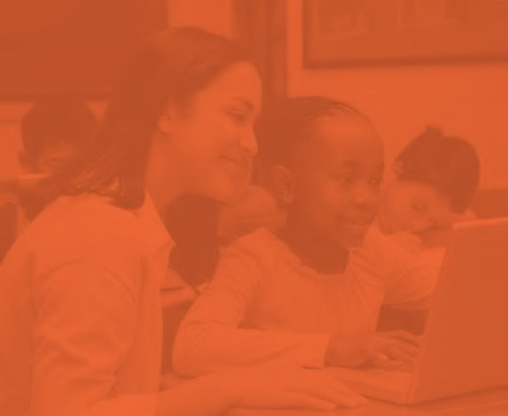

a variety of ways.”

Mark Sanderson,

Senior ICT Consultant, Herefordshire Learning and Achievement Service

If you are a UK customer, please contact us using the details below:

educationcity.com

+44 (0)1572 725080

[customerservice@educationcity.com](mailto:customerservice@educationcity.com)

If you are a customer outside of the UK, please contact us using the details below:

edmentuminternational.com

+44 (0)1572 492576

[international@edmentum.com](mailto:international@edmentum.com)

Edmentum International c/o EducationCity Ltd 8/9 Saddlers Court Oakham, Rutland

LE15 7GH, UK

EducationCity